**REQUIREMENT ANALYSIS PHASE**

| **Date** | **25-06-2025** |
| --- | --- |
| **Team Id** | LTVIP2025TMID31256 |
| **Project Name** | **CRM Application for Jewel Management** |
| **College Name** | **Ideal Institute Of Technology** |

* **Customer Journey Map**

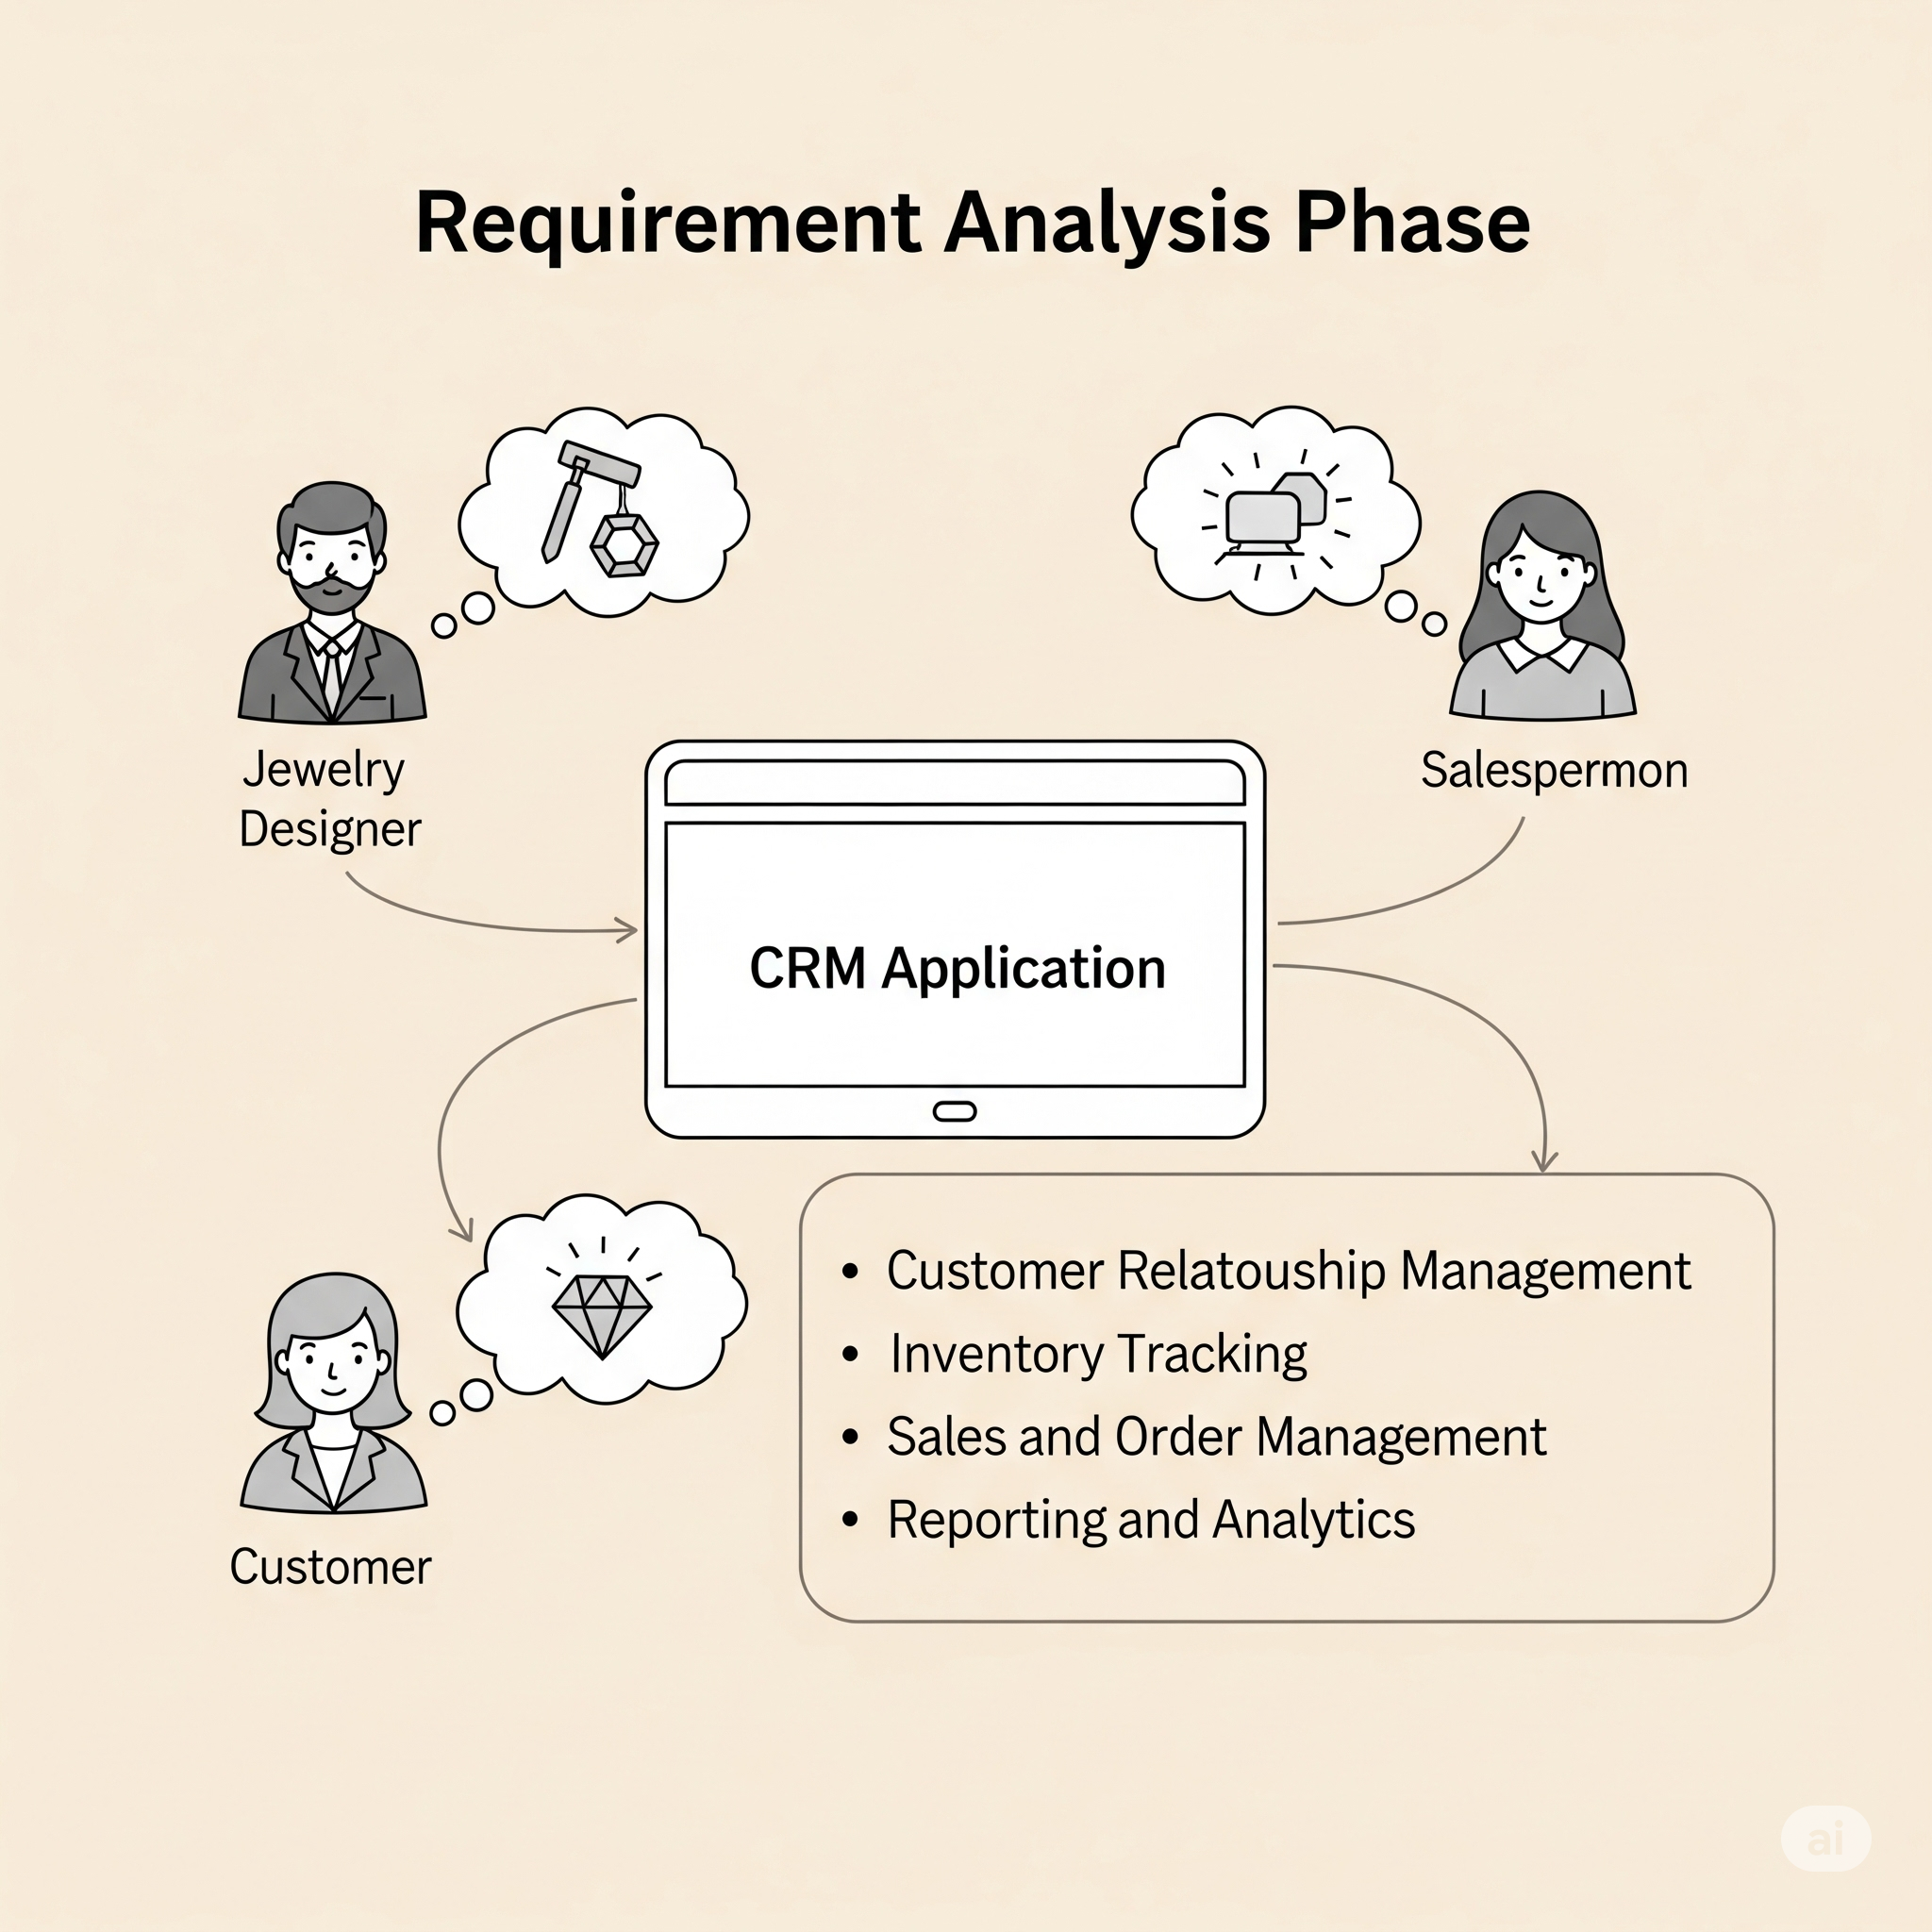

* **Solution Requirements**

## ✅ Solution Requirements

### **Functional Requirements**

1. **Customer Profile Management**
   * Create and update customer records.
   * Maintain purchase history and preferences.
   * Track birthdays, anniversaries, and style interests.
2. **Jewelry Order Management**
   * Create, update, and track standard and custom jewelry orders.
   * Upload design images and specifications.
   * Notify customers at key stages: design approval, production, ready for pickup/delivery.
3. **Inventory Management**
   * Track stock levels of gold, diamonds, and finished products.
   * Alert for low-stock or high-demand items.
   * RFID/barcode scanning for physical tracking.
4. **Sales & Billing**
   * Generate quotations and invoices.
   * Apply discounts, taxes, and loyalty points.
   * Integration with payment gateways.
5. **Loyalty & Rewards System**
   * Accrue and redeem points per purchase.
   * Tiered customer levels (e.g., Silver, Gold, Platinum).
   * Personalized offers based on loyalty data.
6. **Customer Interaction & Communication**
   * Automated SMS/Email notifications for order progress and promotions.
   * Festival and occasion greetings.
   * Feedback collection after sales.
7. **Dashboard & Reporting**
   * Sales reports by date, product, or customer segment.
   * Inventory movement and reorder reports.
   * Customer behavior analytics.
8. **Mobile & Web Application Interface**
   * Responsive user interface for in-store and customer use.
   * Digital receipts, designs, and catalog access.
   * Real-time notifications and customer service chatbot.

**6. Mobile App / Field Technician Interface**

* Offline capability.
* Work order checklist, photo upload, digital signatures.
* Navigation assistance.
* Ability to update status, log time and materials.

**7. Customer Communication**

* Appointment confirmations, reminders via SMS/email.
* Real-time ETA tracking for customers.
* Feedback collection after service.

**8. Asset & Equipment Management**

* Maintain asset service history.
* Track warranties and contracts.
* Monitor IoT-connected devices for proactive service.

**9. Analytics & Reporting**

* SLA compliance, first-time fix rate (FTFR), travel time, technician utilization.
* Real-time dashboards for dispatchers and management.
* Historical data trends for predictive maintenance.

### **🔒 Non-Functional Requirements**

* **Performance**
  + **Low latency interactions, especially during peak shopping seasons.**
  + **Fast response times on web and mobile platforms.**
* **Security**
  + **Role-based access (admin, sales rep, manager).**
  + **Data encryption for sensitive customer and transaction data.**
* **Scalability**
  + **Support for multi-branch jewelry chains.**
  + **Cloud deployment for regional/global scaling.**
* **Integration**
  + **POS and ERP systems (e.g., Tally, Zoho).**
  + **Payment gateways (Razorpay, Paytm, Stripe).**
  + **Email/SMS service providers.**
* **Configurability**
  + **Custom workflows for order approval and production.**
  + **Dynamic customer segmentation for marketing.**
* **Usability**
  + **Intuitive UI for both store employees and customers.**
  + **Multi-language support for diverse customer base.**
* **Availability**
  + **99.9% uptime with auto-failover.**
  + **Scheduled backups and disaster recovery.**

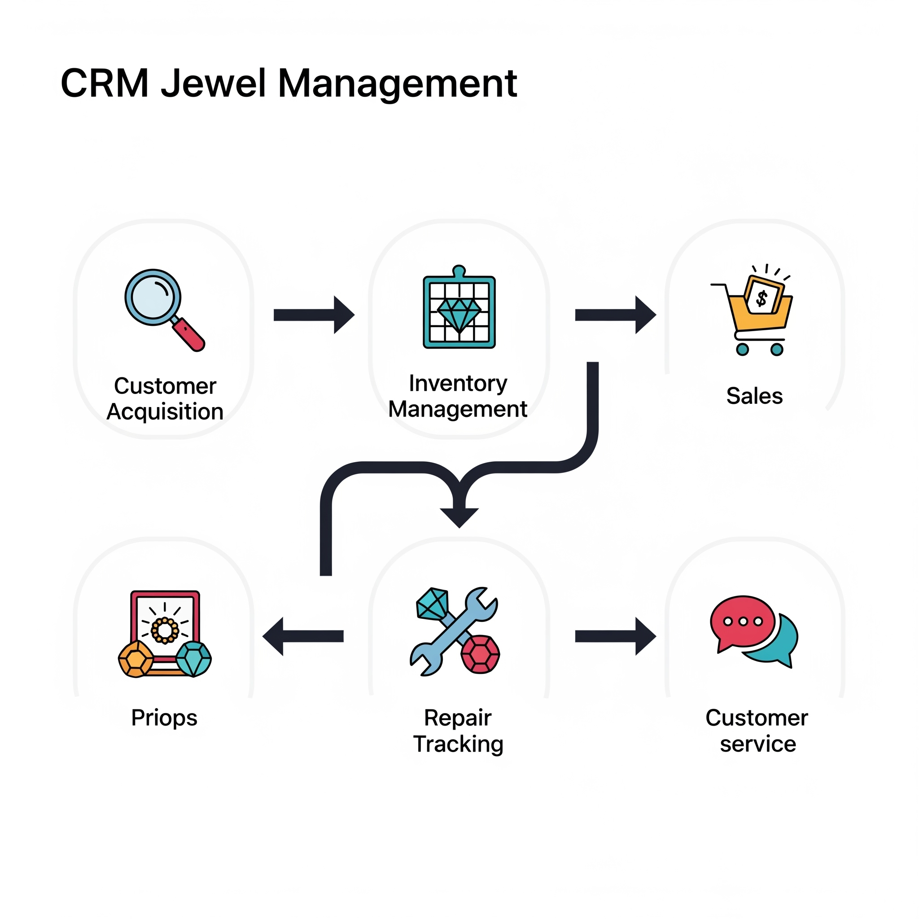

**Level 1 DFD – Full Workflow of CRM application for jewel management:**

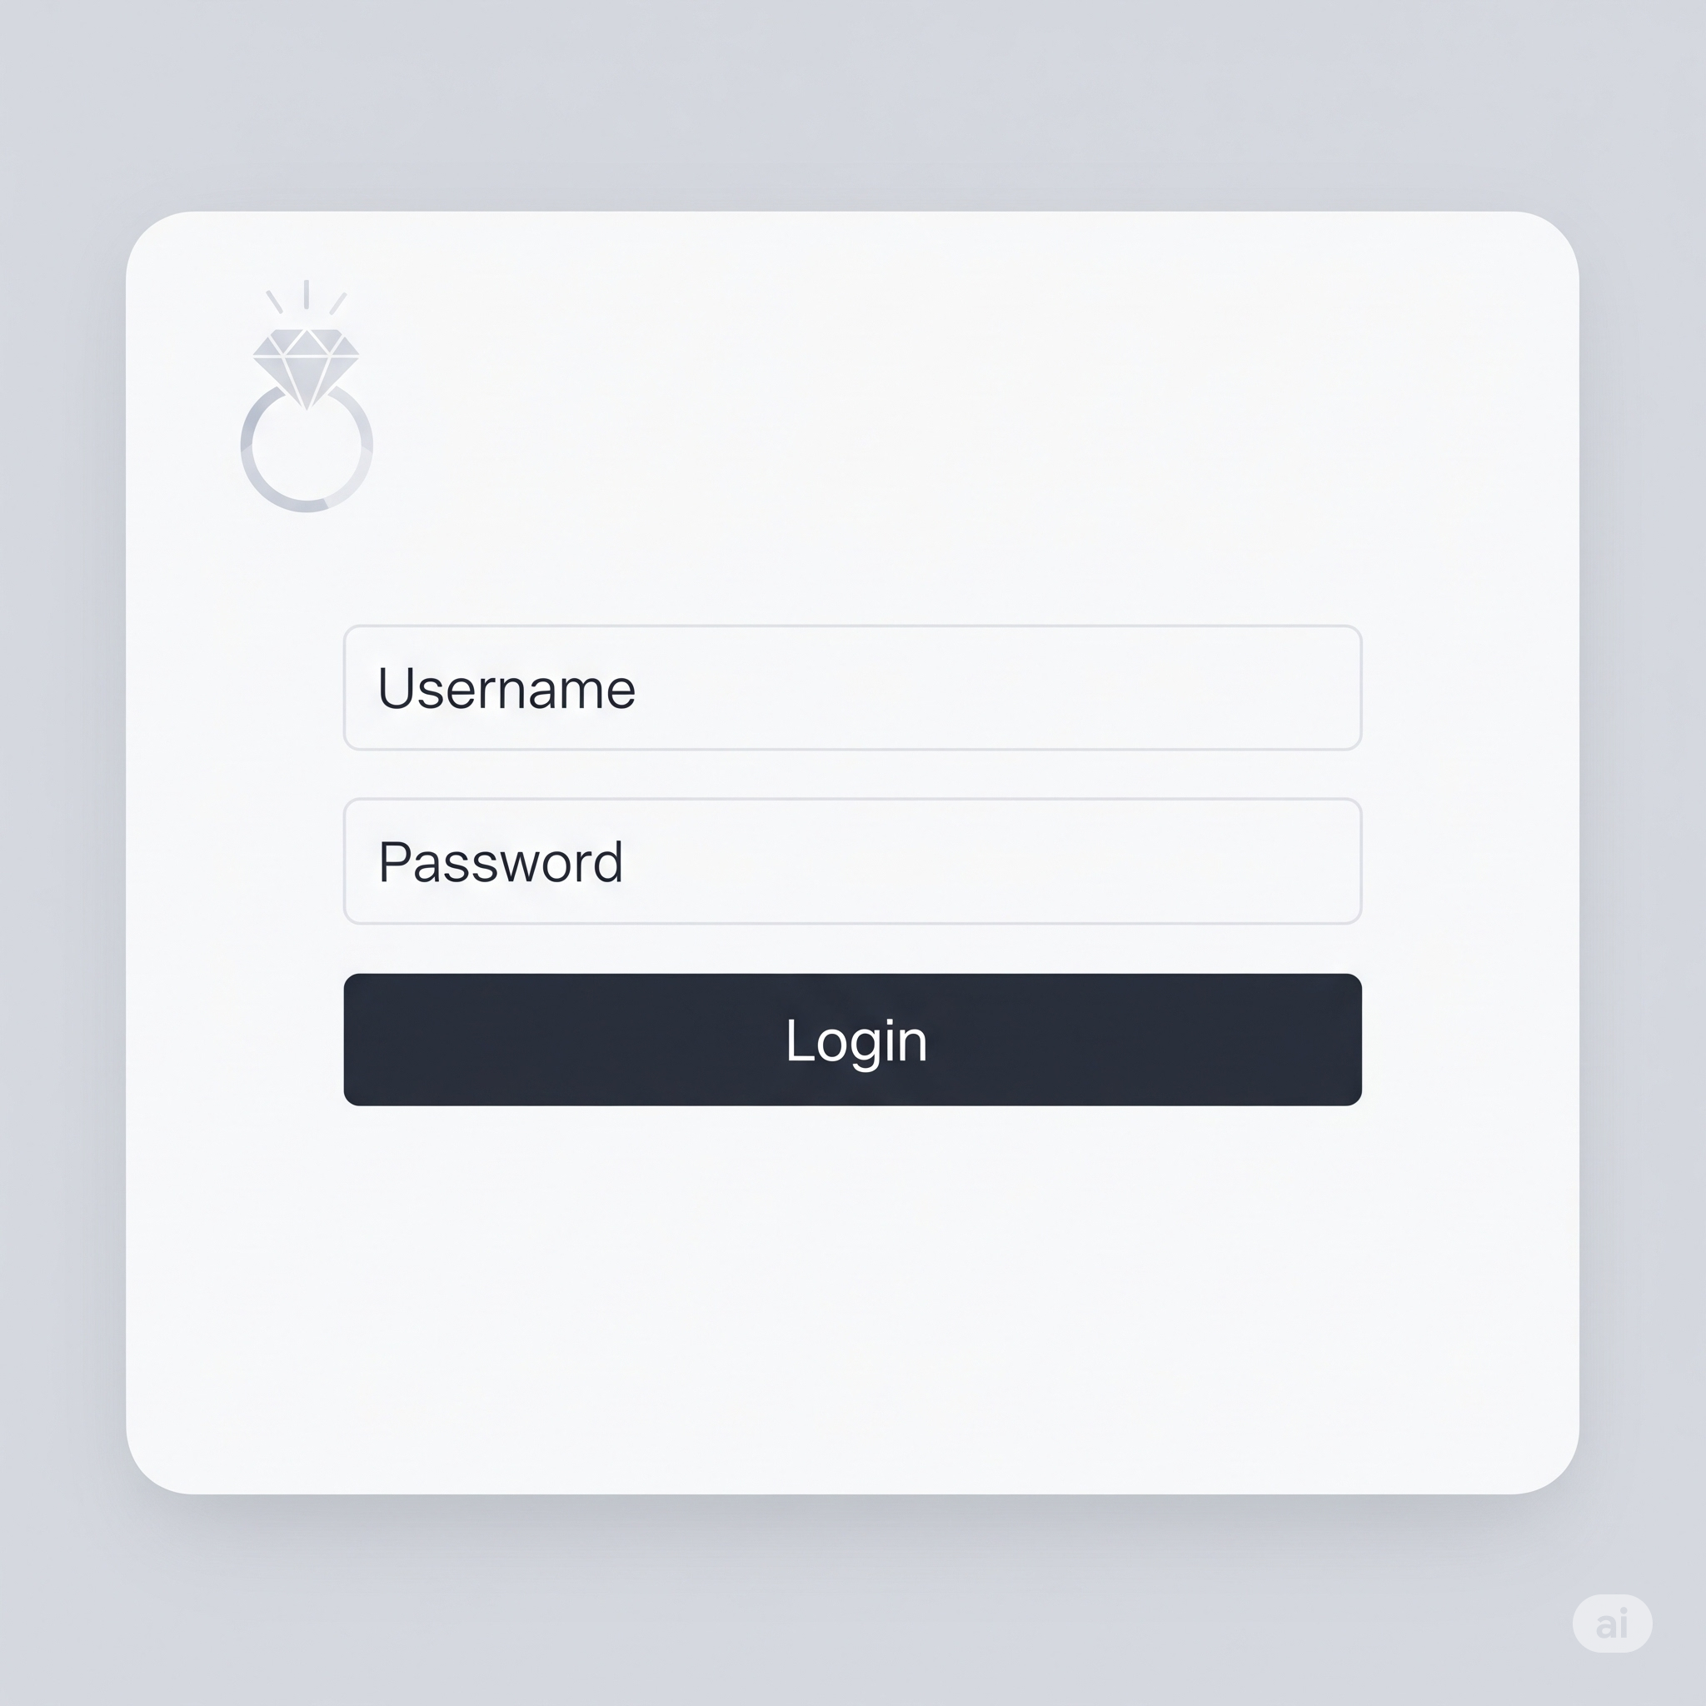

**Data Flow Diagram (DFD) - User Authentication Module for CRM Application for Jewel Management**

## User Stories

| **#** | **User Role** | **User Story** | **Benefit** |
| --- | --- | --- | --- |
| **1** | **Sales Executive** | **As a sales executive, I want to create and track custom jewelry orders.** | **To streamline design-to-delivery process.** |
| **2** | **Store Manager** | **As a store manager, I want to view daily sales and inventory reports.** | **To make informed decisions and restock timely.** |
| **3** | **Customer** | **As a customer, I want to receive updates on my jewelry order.** | **To stay informed and trust the store’s service.** |
| **4** | **Developer** | **As a developer, I want configurable workflows for different stores.** | **To support business-specific customizations.** |
| **5** | **Marketing Lead** | **As a marketer, I want to send offers to customers before anniversaries.** | **To increase customer engagement and sales.** |
| **6** | **Support Agent** | **As a support agent, I want to access order and profile details quickly.** | **To resolve customer queries efficiently.** |
| **7** | **Customer** | **As a customer, I want to earn and redeem loyalty points seamlessly.** | **To feel rewarded and increase repeat purchases.** |
| **8** | **Admin** | **As an admin, I want to manage access control and user roles.** | **To ensure secure access based on employee roles.** |
| **9** | **Inventory Officer** | **As an officer, I want real-time alerts on low-stock items.** | **To avoid delays in fulfilling high-demand items.** |

## 

## 

## 

## 

## 

## 

## 

## 

## Technology Stack (Architecture & Stack)

| **Layer** | **Purpose** | **Technologies** |
| --- | --- | --- |
| **Presentation Layer** | **Web & Mobile Interface** | **React.js, Flutter, Vue.js** |
| **Application Layer** | **Business Logic, Authentication** | **Node.js, Django, OAuth 2.0, JWT** |
| **Data Layer** | **Storage and Backup** | **PostgreSQL, MongoDB, AWS S3** |
| **Integration Layer** | **APIs and External Connectivity** | **REST APIs, Firebase, Razorpay, WhatsApp Business API** |
| **Infrastructure Layer** | **Deployment, CI/CD, Monitoring** | **AWS, Docker, GitHub Actions, Prometheus** |
| **Optional Add-ons** | **Intelligence and Automation** | **AI-based Recommendations, RPA, Predictive Analytics** |

* **Technology Stack (Architecture & Stack)**

